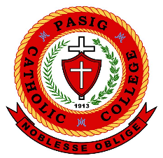
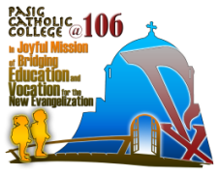
Pasig Catholic College
CHRISTIAN FORMATION - SENIOR HIGH SCHOOL
School Year 2018 – 2019
PCC @ 106: “In Joyful Mission of Bridging Vocation and Education Towards
the New evangelization”

SAINTIFY PROFILE

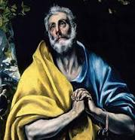

Name of the Saint: St. Peter the Apostle
Real Name: Simon
Birth date: 1 AD
Birth place: Bethsaida
Death: 64 CE
Parents: Jonah

Brief description of his/her environment:
As far as can be judged, Peter was a member of
The ordinary people of Palestine, who were normally
Considered by educated Jewish classes to belong to
Am harez, the people of the land. This term was used in a
Derogatory fashion to describe those who were ignorant of the niceties and deeper values of Judaism and the Jewish way of life. In addition, Peter was a Galilean and therefore shared the spirit of independence and opposition to Jerusalem which was traditional in that Northern Province.
Narrate his/her values, belief in life and how did he/she upheld it.
Although he had many strengths, Peter had weaknesses, too. He complained that he and the other Apostles had given up everything to follow Jesus and wanted to know what he would get for this sacrifice. At the Lord’s command, he walked on water, but then lost his faith in Jesus’ power and sank in the sea.
Other important information about the saint (special prayer, devotion, known miracle attributed to him/her, etc)
Peter, who was also known as Simon Peter of Cephas, is considered the first Pope. Despite his papacy, Peter had humble beginnings and became one of the Twelve Apostles of Jesus. While Peter's chief feast day is June 29, he is also honored on February 22 and November 18. In liturgical art, he is depicted as an elderly man holding a key and a book. His symbols include an inverted cross, a boat, and the cock.

Symbol/s of the saint and what does it mean? (picture and meaning or significance of the symbol)


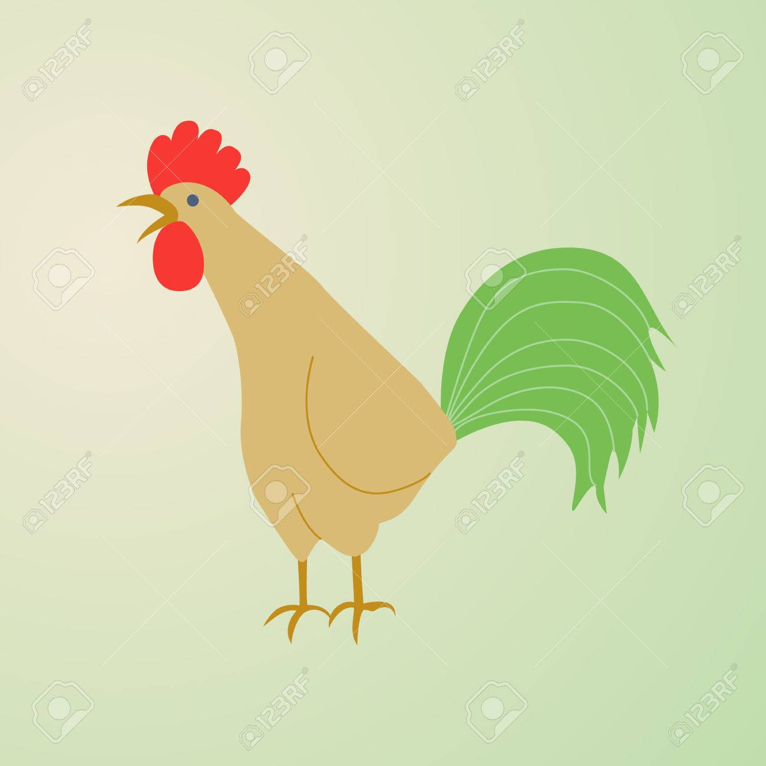
A Pair of Overlapping Keys. The keys represent Peter’s authority as the leader of the
Twelve apostles and the head of the early Church.
A Shepherd’s Staff. represents Peter’s
Role as chief shepherd of Jesus’ flock.
An Upside-Down Cross. represents
The type of cross upon
Which Peter was martyred during the
Persecution of the emperor Nero.
A Cock or Rooster Crowing. represents
Peter’s threefold denial of
Jesus in the high priest’s courtyard.

RUBRICS for Mini Task 1
Criteria | 10 | 8 | 6 | 4
Completion of List (x2) | The short list is complete with descriptions. | The short list is 80% complete as well as the description. | The short list is 60 % complete as well as the description. | The short list is 40% or less complete as well as the description.
Promptness of Submission (x2) | Submitted on the exact time | One day late submistted | Two days late submitted | Three or more days late submitted
TOTAL (40)
RUBRICS for Mini Task 2
Criteria | 10 | 8 | 6 | 4
Completion of List (x2) | The profile is complete with the necessary contents. | The profile is 80% complete with the contents. | The profile 60%is complete with the contents. | The profile is 40% complete with the necessary contents.
Promptness of Submission (x2) | Submitted on the exact time | One day late submitted | Two days late submitted | Three or more days late submitted
Significance of Contents  (x2) | The contents of the profile described concretely who the saint is giving the important details. | The contents of the profile somehow described concretely who the saint is but some important details are missing. | The contents of the profile described the saint but the bulk of the important details are missing. | The contents of the profile described the saint but important details still remain in question.
TOTAL (60)

RUBRICS FOR PERFORMANCE TASK Part 1 (50% of total PeTa)
Criteria | 10 | 8 | 6 | 4
Evidence of Preparation (x3) | All the elements in the saint being emulated is seen in the saintified picture. | 80% of the elements in the saint being emulated is seen in the saintified picture. | 60% of the elements in the saint being emulated is seen in the saintified picture. | 40% of the elements in the saint being emulated is seen in the saintified picture.
Promptness of Submission (x3) | Submitted on the exact time | One day late submitted | Two days late submitted | Three or more days late submitted
Reflections and Realizations  (x4) | The contents of the reflection paper express genuine and sincere realization as the student prepares and accomplishes the task | The contents of the reflection paper express somehow genuine and sincere realization as the student prepares and accomplishes the task | The contents of the reflection paper express the realization as the student prepares and accomplishes the task but it seems all is for compliance. | The contents of the reflection paper express realization but done without much though and is not quite sincere.
TOTAL (100)

Name of Student: Ciriaco, Jan Adrian M. Level/Section: 12 – Pope Benedict XVI

Sources: https://www.britannica.com http://saintsresource.com http://biography.yourdictionary.com http://rediscover.archspm.org

